**NAME : AJAY K**

**ROLL NO : CH.EN.U4CCE22003**

**Compile-time Polymorphism (Method Overloading)**

**Program:**

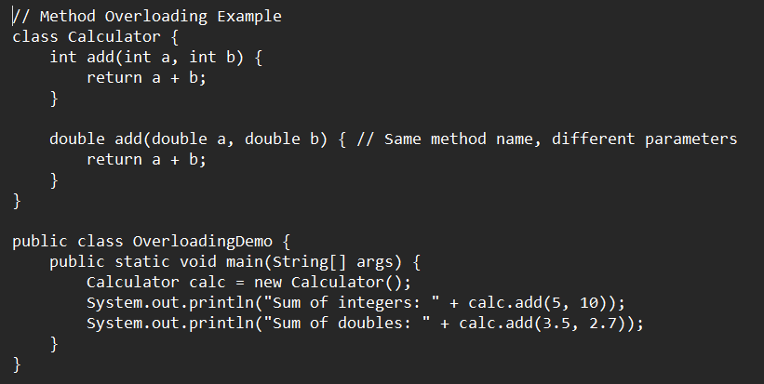

**Output:**

**Runtime Polymorphism (Method Overriding)**

**Program:**

**Output:**

